# Playing The Game

## House Rules

I have a few weird rules that I use to make things interesting (and hopefully more fun):

* **Cut Scenes**: At certain points (character intros, BBEG monologues, environmental events, etc), the DM will call "Cut Scene," at which point there is no game interaction. Once the cut scene has ended, the DM will call "Action."
* **Drama**: Everyone starts the game with one Drama Point. Drama Points are refreshed at every level-up (which will happen during story breaks, at the end of a small arc). They can also be earned through outstanding roleplay, or by the DM taking momentary control of a character or overriding a dice roll for the sake of the story. A Drama Point can be used to:
  + Interrupt a cut scene and act
  + Treat a d20 roll as a natural 20 (can be declared before or after the roll)
  + Automatically roll the maximum on a dice roll (single or multiple dice)
  + Other instances as specified by the DM
* **Firing Into Groups**: I use hex maps instead of squares. When firing at a target that has any other creature (friend or foe!) in an adjacent hex, a miss has an opportunity of hitting something else. On a miss, roll a d6. Starting with the topmost hex as 1 and proceeding clockwise, count off hexes to the number rolled. If anything is occupying that hex (friend or foe!), make another attack roll against that target.
* **Healing Potions**: Drinking a healing potion can be done as a free action, standard action, or full-round action. When a free action is used, assume all dice for healing roll a 1 (for instance, a potion of *Cure Light Wounds* taken as a free action would only recover 2HP). The rules for drinking a potion as standard action are unchanged. If a full-round action is used, assume all dice roll their maximum.
* **Casting Beyond Limits:** Any caster can attempt to cast a spell that they know but have no more spell slots remaining to cast. Make a Fortitude save with a DC of 17, plus the spell’s level, plus the number of checks already attempted (regardless of level or successes). If the check is successful, the spell is cast as normal. If the check fails, the character takes a Negative Level (page 562). Negative Levels gained in this way are removed automatically (without a check) at the rate of one per 8 hours of rest.
* **Weapon Grades:** Non-magical weapons are graded Standard, Superior, and Masterwork.
  + Standard weapons are exactly as presented in the book
  + Superior weapons cost 5 times their book value, and provide either a +1 to hit or +1 to damage
  + Masterwork weapons cost 20 times their book value, and provide a +1 to hit and damage. They do not count as magical.
  + Only Masterwork weapons can be enchanted. A basic enchantment retains (but does not improve) the +1, and now counts as magical.
* **Weapon Breakage:** Rolling a natural 1 isn’t just a miss, it’s a critical failure, and with that comes the risk of a weapon breaking. After rolling a natural 1 to hit, roll a die corresponding to the grade of the weapon. If that die also rolls a 1, the weapon has irreparably broken.
  + Standard: d2
  + Superior: d4
  + Masterwork: d6
  + Basic enchantment: d8
  + Any mix of two additional plusses or abilities (i.e., +3 or +2 and vorpal): d10
  + Any mix of three additional plusses or abilities: d12
  + Any mix of four additional plusses or abilities: d34 (yes I have one)
  + Anything more powerful: d100

## Character Creation

### Guidelines

* + Playable races are listed below (oops all elves!). Appearance and family names are given below for reference.
  + All core classes are available except for Barbarian and Monk.
  + Stat generation is by the Purchase method as detailed on Pages 15-16, using the Epic Fantasy value of 25 points. No racial bonuses are granted.
  + Otherwise, character creation uses the 3.5 Edition **Player's Handbook** and can draw from the **3rd Edition Forgotten Realms** book and the **Player's Guide to Faerûn**. No other sources will be used.
  + Characters start at **3rd level**!
  + Equipment can be added without regard to price as long as no one item exceeds 250gp and the total does not exceed 500gp. This budget is not retained - After equipment has been purchased, roll as usual for starting gold.
  + We will be using encumbrance with light, medium, and heavy loads, so plan accordingly!
  + Languages - Oh boy, let’s get into some real fun. [I have a whole document on this](https://docs.google.com/document/d/1ypKhGcTwxMw_bSKuojoWT8snD5z2DGl99ufLH2RX07E/edit?usp=drive_link).
* Origins are left up to the players, with certain caveats
  + Your character was raised in [Evereska](https://forgottenrealms.fandom.com/wiki/Evereska) or the surrounding [Greycloak Hills](https://forgottenrealms.fandom.com/wiki/Greycloak_Hills). You are enrolled in the Academy of Arms and Magic and are about to complete your studies (even clerics, paladins, rangers, and druids, though most of your studies have been at a temple or outside the city).
  + You are familiar with the other characters and may have intertwining backgrounds, so collaboration is important.
  + Characters must choose a patron deity from among the [Seldarine](https://forgottenrealms.fandom.com/wiki/Seldarine), [Bahamut](https://forgottenrealms.fandom.com/wiki/Bahamut), [Mystra](https://forgottenrealms.fandom.com/wiki/Mystra), or [Selûne](https://forgottenrealms.fandom.com/wiki/Sel%C3%BBne) (how devout you are is up to you). [I have a separate document on this as well](https://docs.google.com/document/d/17v1cB-DfJErmcbNsmLcFy7eQ4OHLhORVf6M2zpq8fbM/edit?usp=drive_link), as a few clarifications below.
  + Detail is good, but be aware that anything in your background is fodder for the DM to haunt you (which makes it even more fun).
  + No evil alignments, no trying to pass off Murderhobo as Chaotic Neutral.
  + Characters should have some sort of goal or aspiration.
  + I may make strong suggestions, but am rather flexible.
* Elven Traits (These override the book)
  + **Elven Immunities:** Elves are immune to magic sleep effects and get a +2 racial saving throw bonus against enchantment spells and effects.
  + **Infravision:** Elves can shift their eyesight into the infrared spectrum and see heat patterns (all hail 2nd Edition!). Heat sources such as torches can interfere with this vision.
  + **Keen Senses:** Elves receive a +2 racial bonus on Perception skill checks.
  + **Subrace Bonus:** Each subrace has a different bonus as described below.
* Miscellaneous
  + Characters start with a +2 miscellaneous bonus to one Knowledge skill
  + Characters start with a +2 miscellaneous bonus to one of the following skills:
    - Diplomacy
    - Handle Animal
    - Heal
    - Linguistics
    - Ride
    - Sleight of Hand
    - Spellcraft
    - Stealth
    - Survival
* Playable races
  + **Sun/Gold Elf (Ar'Tel'Quessir)**
    - **Skin color:** Bronze
    - **Hair color:** Black, copper, golden blond, red
    - **Eye color:** Black, copper, gold, green, hazel, or silver, with a liquid appearance
    - **Family names:** Aelorothi, Darthammel, Drathinael, Echorn, Everdawn, Mournthuil, Sunstar, Sunstone
    - **Native Language:** Espruar or Sethic
    - **Bonus:** The High Lore - Sun Elves are a proud people who consider themselves to be the defenders of all Tel’Quessir and scions of the great lost empires - despite their heritage being one of destruction and war. Sun Elves have a +2 situational bonus on all Knowledge checks relating to elven history (this is not restricted to just Knowledge - History).
  + **Moon/Silver Elf (Teu'Tel'Quessir)**
    - **Skin color:** Fair, sometimes with blue tint
    - **Hair color:** Black, blue, silvery white
    - **Eye color:** Green or blue with golden flecks
    - **Family names:** Ashmantle, Blackgem, Deephaven, Embergold, Mistwinter, Moondancer, Silvercloak, Stardawn, Whitethorn
    - **Native Language:** Espruar
    - **Bonus:** Cosmopolitan - Moon Elves are creatures of the world. Despite Evereska and Evermeet being generally closed enclaves, Moon Elves remain far and away the most common of the Tel’Quessir among the other races, and are generally in favor of harmony with them. Moon Elves have a +2 situational bonus on Charisma-based checks when interacting with non-elven races.
  + **Wood/Copper Elf (Or'Tel'Quessir)**
    - **Skin color:** Copper, tan
    - **Hair color:** Black, blond, brown, copper red
    - **Eye color:** Green, brown, hazel
    - **Family names:** Blueleaf, Darkhollow, Duskwood, Greengrass, Shadowtop, Silverbark, Talloak
    - **Native Language:** Espruar or Aythar
    - **Bonus:** Children of the Woods - Copper Elves have been steeped in nature for so long that their relationship with it is instinctual now, and even those rare few who live in cities still maintain this bond. Copper Elves have a +2 situational bonus on Knowledge checks relating to woodlands and a +2 situational bonus on Charisma-based checks when interacting with fae and undomesticated creatures native to woodland.

## A Quick Note on Character Religion

There are *way* too many deities in the Forgotten Realms, especially considering this is a game that will dabble in religion and the machinations of gods. For the sake of simplicity and keeping the DM’s brain as intact as it can be, there are a number of them who simply don’t appear in the game. While I don’t want to give away which gods in the larger pantheon this entails, I do want to point out which of the Seldarine will be in the game.

It’s perfectly acceptable to go against type here (especially if there are multiple options for your character), but in general, the worshippers listed are highly typical. Some classes have deities that appeal to them specifically, but Clerics and Paladins can be devoted to any of these.

* **Correllon Larethian** - The chief elven deity, held in highest regard by most Sun Elves.
* **Sehanine Moonbow** - Correllon’s consort and protector, held in highest regard by most Moon Elves.
* **Erevan Ilesere** - The patron of rogues and tricksters.
* **Hanali Celanil** - The patron of lovers, artists, and poets.
* **Labelas Enoreth** - The patron of those seeking knowledge.
* **Rillifane Rallathil** - Held in highest regard by most Copper Elves and almost universally by elven druids.
* **Solonor Thelandira** - The patron of archers and rangers.
* **Bahamut** - The god of justice and good-aligned dragons. Most elven worshipers are paladins or justices.
* **Mystra** - The goddess of magic. Those who practice magic give her reverence regardless of who they worship.
* **Selûne** - The goddess of the moon. She is worshiped by those who quest or wander or seek lost things.

Planning Ahead

There are a number of prestige classes available to characters as they advance. All have specific requirements, but many of them have in-game roleplaying requirements. For example, becoming a Bladesinger isn’t as simple as meeting the stat thresholds - a character must be invited to train with a Bladesong master.

* Arcane Devotee - wizards and sorcerers who champion a particular faith
  + Spellcasting: Ability to cast 4th-level arcane spells
  + Skills: Knowledge (Religion) 8 ranks, Spellcraft 8 ranks
  + Feats: Enlarge spell
  + In-game: Correllon or Mystra as patron deity
* Archmage - The mightiest of spellcasters, second only to High Magi.
  + Spellcasting: Ability to cast 7th-level arcane spells
  + Skills: Knowledge (Arcana) 15 ranks, Spellcraft 15 ranks
  + Feats: Skill Focus (Spellcraft), Spell Focus in two different schools
  + In-game: specific training under a High Mage
* Divine Champion - Devout holy warriors
  + Class: Fighter, Paladin, Ranger
  + Base Attack Bonus: +7
  + In-game: Specific blessing of one’s deity
* Divine Disciple - Paragons of a deity
  + Class: Cleric, Druid, Paladin, Ranger
  + Spellcasting: Ability to cast 4th-level divine spells
  + Skills: Diplomacy 5 ranks, Knowledge (Religion) 5 ranks
  + In-game: Specific blessing of one’s deity

## Images for example and inspiration

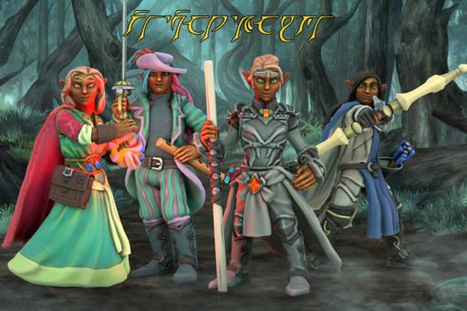  
**Sun Elves**

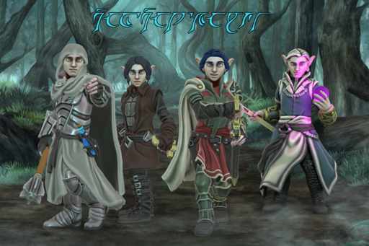

**Moon Elves**

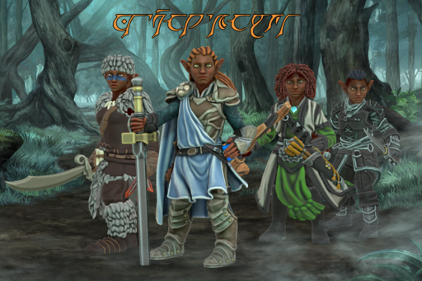

**Copper Elves**

## Sample Hero Forge Templates

The character visuals I’m using for the game come almost entirely from [Hero Forge](https://www.heroforge.com). The templates below generally cover the range of eye and hair colors/textures for each subrace. In general, the options for them are:

* **Sun Elves:** Face - “Smooth Features.” Hair - lightly textured hair
* **Moon Elves:** Face - **“**Heroic Features.” Hair - smooth hair
* **Copper Elves:** Face - “Delicate Features.” Hair - curly, kinky, textured hair

If you haven’t played around in Hero Forge, go nuts! There are an impressive amount of customization options. You can either take a screenshot with the built-in tool, or send a link to the character you’ve created once you make an account.

| [**Sun Elf Fem 1**](https://www.heroforge.com/load_config%3D41413419/) | [**Sun Elf Fem 2**](https://www.heroforge.com/load_config%3D41413425/) | [**Sun Elf Masc 1**](https://www.heroforge.com/load_config%3D41413439/) | [**Sun Elf Masc 2**](https://www.heroforge.com/load_config%3D41413466/) |
| --- | --- | --- | --- |
| [**Moon Elf Fem 1**](https://www.heroforge.com/load_config%3D41413523/) | [**Moon Elf Fem 2**](https://www.heroforge.com/load_config%3D41413577/) | [**Moon Elf Masc 1**](https://www.heroforge.com/load_config%3D41413472/) | [**Moon Elf Masc 2**](https://www.heroforge.com/load_config%3D41413498/) |
| [**Copper Elf Fem 1**](https://www.heroforge.com/load_config%3D41413396/) | [**Copper Elf Fem 2**](https://www.heroforge.com/load_config%3D41413309/) | [**Copper Elf Masc 1**](https://www.heroforge.com/load_config%3D0eb13c20-4763-47e4-abd3-7b9fa83e01e3/Copper%20Elf%20Masc%201/) | [**Copper Elf Masc 2**](https://www.heroforge.com/load_config%3D41413374/) |